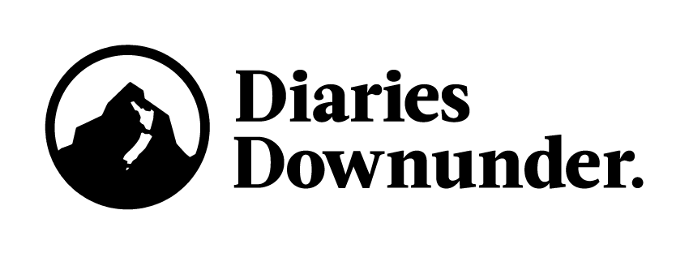

Ministry of Education Integrated Learning Films: Transcriptions

School 5 - Tai Wananga College.

00:03 to 00:06 Toby Westrupp: Principal
Our ethos statement is ‘Giving life to learning and purpose to life.’

00:07 to 00:21 Ian Tairea: Director of Innovation
What that means for me is that we want to give life to learning, we want to make learning interesting. We don’t want learning to something that’s being told to a student, we want learning to be something that’s experienced, something that they can engage with.

00:22 to 00:43 Tuhoea Joshua Watene: Teacher
What makes Tai Wananga unique to other schools is probably a couple of things. First thing is their conditioning and their training that they do every morning. Rain, hail, snow, whatever it is, the kids are out there training. Secondly is that we feed them, so we give them breakfast and we give them lunch. A lot of our Maori kids in particular, a lot of them come to school without lunch.

0:44 to 00:54 Ian Tairea: Director of Innovation
At Tai Wananga Tu Toa we trialled integrated learning this year. So this was really quite exciting. The staff made a conscious decision at the end of last year that we were going to you know, try something new.

00:55 to 01:16 Toby Westrupp: Principal
Project based learning for us is our preferred vehicle for learning. It’s based on inquiry and if our students have the skills and attributes to find solutions from inquiry then they have the ability to learn whatever they like. And that is the essence of being a life-long learner.

01:17 to 01:54 Tuhoea Joshua Watene: Teacher
The most important thing is that kids are passionate about what they’re learning about. If a student is passion driven they will find every avenue to learn. There’s no limit to what subjects are integrated, we don’t go ‘Ok this is going to go here, this subject here, this subject here’. It’s actually a naturally recurring thing that happens. So in Matthew Walmsley’s case, it involves design, he’s gotta learn how to design his jewellery and then he has to learn how to make it so that involves technology and then all of a sudden he can see a business. So, now we’re involving business studies and marketing studies, it’s just naturally occurring integration.

01:54 to 02:29 Matthew Walmsley: Year 12 Student
The big theme of our project based learning was the environment. So I wanted to do something that involved recycling. My project was making jewellery out of colouring pencils. Project based learning was one of the main reasons why my parents chose for me to go to Tai Wananga. They really liked how different it was to the normal curriculum and also how much it exposed me to business and marketing and it gave me financial skills that I wouldn’t learn in other subjects. The thing I like about project based learning is you’re able to do what you’re passionate about.

02:30 to 02:57 Ian Tairea: Director of Innovation
The more you learn, the more purpose you can have in life. The more you can contribute to your community, the more you can contribute to your whanau. If we can make learning fun, if we can make learning engaging, we can give our Taiohi more purpose in life. One example of an integrated topic that we trialled this year was Super Rugby. That was a collaboration between the English Department and Physical Education that required them to reflect on ‘How does super rugby impact New Zealand as a society?’

02:57 to 03:38 Te Aurere: Year 12 Student
We done our super rugby assessment which combined English and PE together which made us do two assessments for one project. And since we completed two assessments we managed to have quite a lot of free time, and with my free time I used to go on the computers and make rugby videos and edit videos.

When I was year 9, we had no sort of technology like this and it wasn’t until last year was when we got our equipment and it was like new to all of us. I just found out that I liked video editing because I’d never done it before, something new and I’m going to continue growing my skills and developing.

03:39 to 04:04 Ian Tairea: Director of Innovation
I think the main successes of the integrated learning and the project based learning has been that students are more engaged in their learning and they’re actually thinking about you know, they’re asking ‘Oh, could we learn about this, could we learn about this.’ They’re starting to drive their own learning and that’s been a big shift for our thinking, where as we, I think traditionally teachers are thinking ‘I’m going to teach them this’ and we’re creating the learning. The more that we let them have a bit more control of that, they’re really buying into it.

04:05 to 04:40 Toby Westrupp: Principal
One of the differences and changes is in our self belief. So, self belief that we actually can achieve and we can achieve those things that we never thought were possible. What comes after self belief is a growing of self-confidence and then the last part is that there’s a desire to celebrate others achievements. So now we have an environment and a culture where it’s fantastic to achieve and it’s a fantastic feeling where we can all celebrate the achievement of others.

04:44
Credits
04:48
Logo
04:52
URL

